**General Chemistry LabII-1112L**

# Lab Report#___5___

Andrew Kalathra, Department of Chemistry and Biochemistry, Lamar University, Beaumont TX 77710

**Title-** Colligative Properties

**Objective**- Observe certain colligative properties, such as freezing point depression, may be used to solve for various variables, such as the molecular weight of a solute.

**Procedure-** 1. First, we set all our equipment up and calibrated them. This included using 2 heat probes that were connected to the LabQuest. We had to calibrate these probes by sticking them both in ice and seeing how far off each was from the freezing point of water – 0.0OC.

2. Next, we made an “Ice Slushy”, or a mixture between of ice and salt, and set our LabQuest instrument up to record the data for 600 seconds.

3. 10 mL of deoinized water was kept into tube (a) along with probe 1

4. Another tube (b)’s weight was recorded, then filled with 10 mL of water, weighted again, gained 2g or urea, weighted again, and probe 2 was placed in it. Then both tube (a) and tube (b) were placed in out ice slushy

5. We started recording the drop in temperature of both solutions, and stopped/pulled out the probe only when the solution was completely frozen.

**Data and Results**

* + - Include graphs and tables of your results.

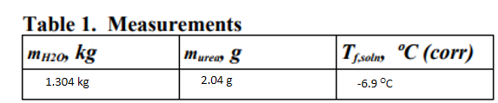

This is from the work below, but it is helpful for solving for the molar mass:

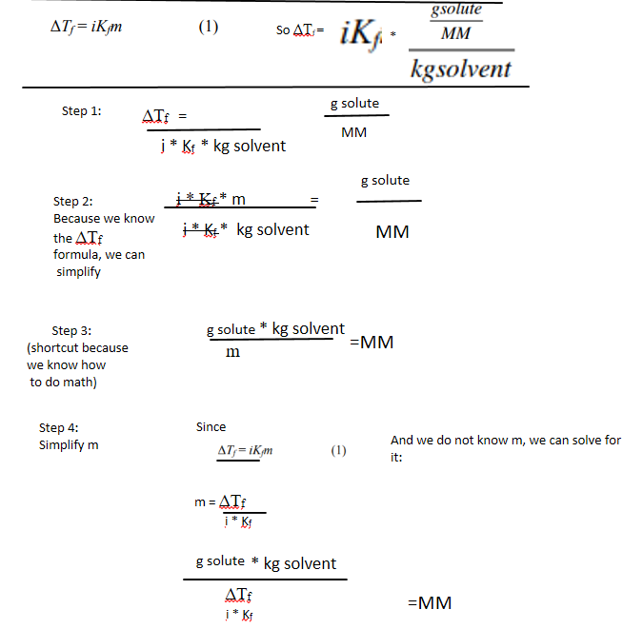  
Using this and the chart befor it, we get:

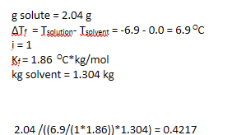

This does not make sense to me, so I have no idea where I went wrong.

If my calculation were (which they were not) we could derive the molar mass of the solute from the mass of the solute, the depression constant of the solvent, the I value of the solute, the change in temperature, and the kg of the solvent.

**Conclusions**

Colligative properties do not depend on the qualities of the molecules, but the quanitity of them.

**Key Questions-**

1. For the ionizing molecule NaCl, estimate its van 't Hoff factor to the nearest integer value. - 2

2. For the nonionizing molecule urea, estimate its van 't Hoff factor to the nearest integer value – 1

3. If an aqueous NaCl solution is 1.00 m, what is the expected freezing point temperature of that solution? - i*Kf*m = 2 * 1.86 * 1 = 3.72

4. Write an equation that relates the solution freezing point, Tf, soln, the solvent freezing point, Tf, solv, and the freezing point depression, ΔTf. -

ΔTf = Tf soln – Tf solv

5. Given that molality, m, is defined as m = (molsolute) / (kgsolvent) - (4)

What is the resulting equation when equation 3 is substituted into equation 1? -

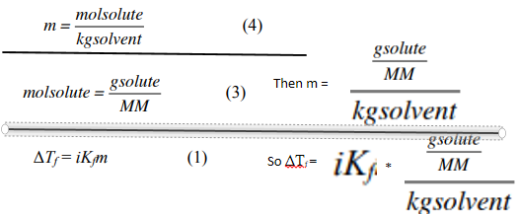

6. The equation derived in the problem above can be rearranged to solve for MM in terms of Kf , ΔTf , g solute, and kg solvent. Write the rearranged equation -

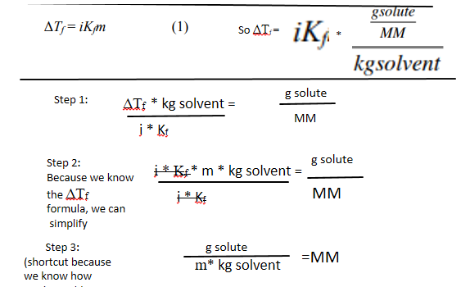

7. Why would pure water not produce a sloped plateau in its time vs. temperature data plot? -

Because the temperature does not change until all of the pure water is transformed into the next phase. The water was not changing phase until all the particles had “slowed down” enough. Hade we kept going, we would have seen a plateau and a slope down after that as the particles all change from liquid to solid, then a really cold solid.

8. Why should the urea solution freezing point be recorded as soon as ice begins to form rather than waiting until a later time? - Because there is a plateau, as the question above suggest, when the solution starts to freeze, so it would be useless to keep the expirement going, and if any calculations require the rate, you answer would be inaccurate.

* Do not forget to attach the signed lab work-out